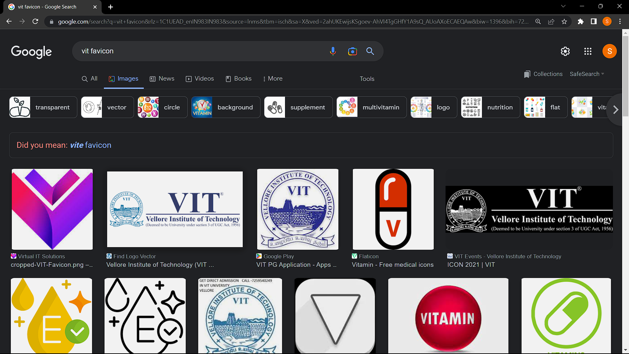

# **NAME: SHIVAM DAVE**

# **Reg no: 21BCB0107**

# **Compiler Design Lab**

# **Digital Assignment 1**

**Aim: C program to identify tokens**

**Code:**

#include <stdio.h>

#include <string.h>

int KeywordFunc(char* a) {

char* arr[] = {"void", "using", "namespace", "int", "include", "<iostream>",

"std", "main()", "cin", "cout", "return", "float", "double",

"string", "endl"};

int i;

for (i = 0; i < 14; i++) {

if (strcmp(arr[i], a) == 0) {

return 1;

}

}

return 0;

}

int main() {

int Op = 0;

int id = 0;

int key = 0;

int sym = 0;

int c = 0;

char str[100];

FILE* file;

char* filename;

filename = "./21bcb0107.txt";

file = fopen(filename, "r");

while (fscanf(file, "%s", str) != EOF) {

if (strcmp(str, "+") == 0 || strcmp(str, "-") == 0 || strcmp(str, "*") == 0 ||

strcmp(str, "/") == 0 || strcmp(str, "^") == 0 || strcmp(str, "&&") == 0 ||

strcmp(str, "||") == 0 || strcmp(str, "=") == 0 || strcmp(str, "==") == 0 ||

strcmp(str, "&") == 0 || strcmp(str, "|") == 0 || strcmp(str, "%") == 0 ||

strcmp(str, "++") == 0 || strcmp(str, "--") == 0 || strcmp(str, "+=") == 0 ||

strcmp(str, "-=") == 0 || strcmp(str, "/=") == 0 || strcmp(str, "=") == 0 ||

strcmp(str, "%=") == 0) {

printf("%s is an operator\n", str);

Op++;

} else if (KeywordFunc(str)) {

printf("%s is a keyword\n", str);

key++;

} else if (strcmp(str, "(") == 0 || strcmp(str, "{") == 0 ||

strcmp(str, "[") == 0 || strcmp(str, ")") == 0 ||

strcmp(str, "}") == 0 || strcmp(str, "]") == 0 ||

strcmp(str, "<") == 0 || strcmp(str, ">") == 0 ||

strcmp(str, "()") == 0 || strcmp(str, ";") == 0 ||

strcmp(str, "<<") == 0 || strcmp(str, ">>") == 0 ||

strcmp(str, ",") == 0 || strcmp(str, "#") == 0) {

printf("%s is a symbol\n", str);

sym++;

} else if (strcmp(str, "\n") == 0 || strcmp(str, " ") == 0 || strcmp(str, "") == 0) {

// Skip whitespace and empty strings

} else if (isdigit(str[0])) {

int x = 0;

if (!isdigit(str[x++])) {

continue;

} else {

printf("%s is a constant\n", str);

c++;

}

} else {

printf("%s is an identifier\n", str);

id++;

}

}

printf("The number of Keywords is: %d\n", key);

printf("The number of Symbols is: %d\n", sym);

printf("The number of constants is: %d\n", c);

printf("The number of identifiers is: %d\n", id);

printf("The number of operators is: %d\n", Op);

return 0;

}

**Input file: 21bcb0107.txt**

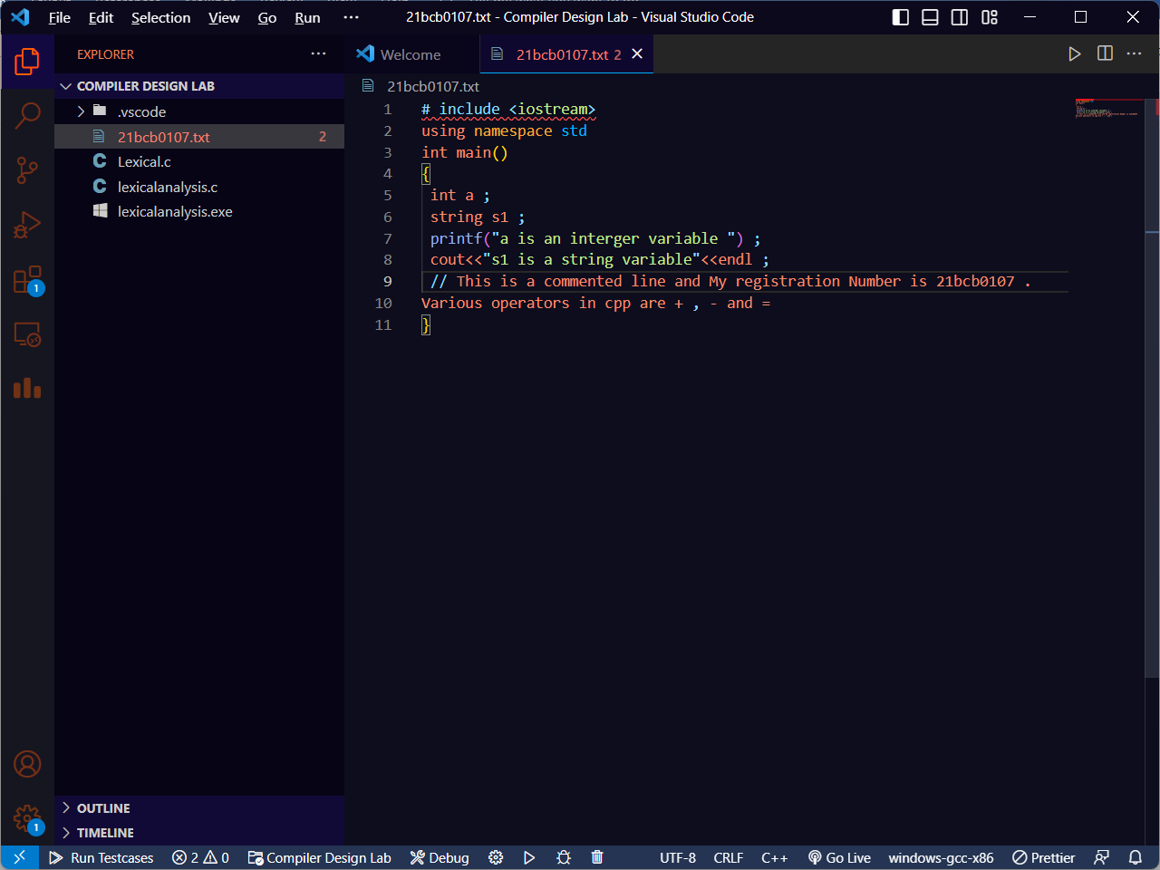

**Output Screenshot:**

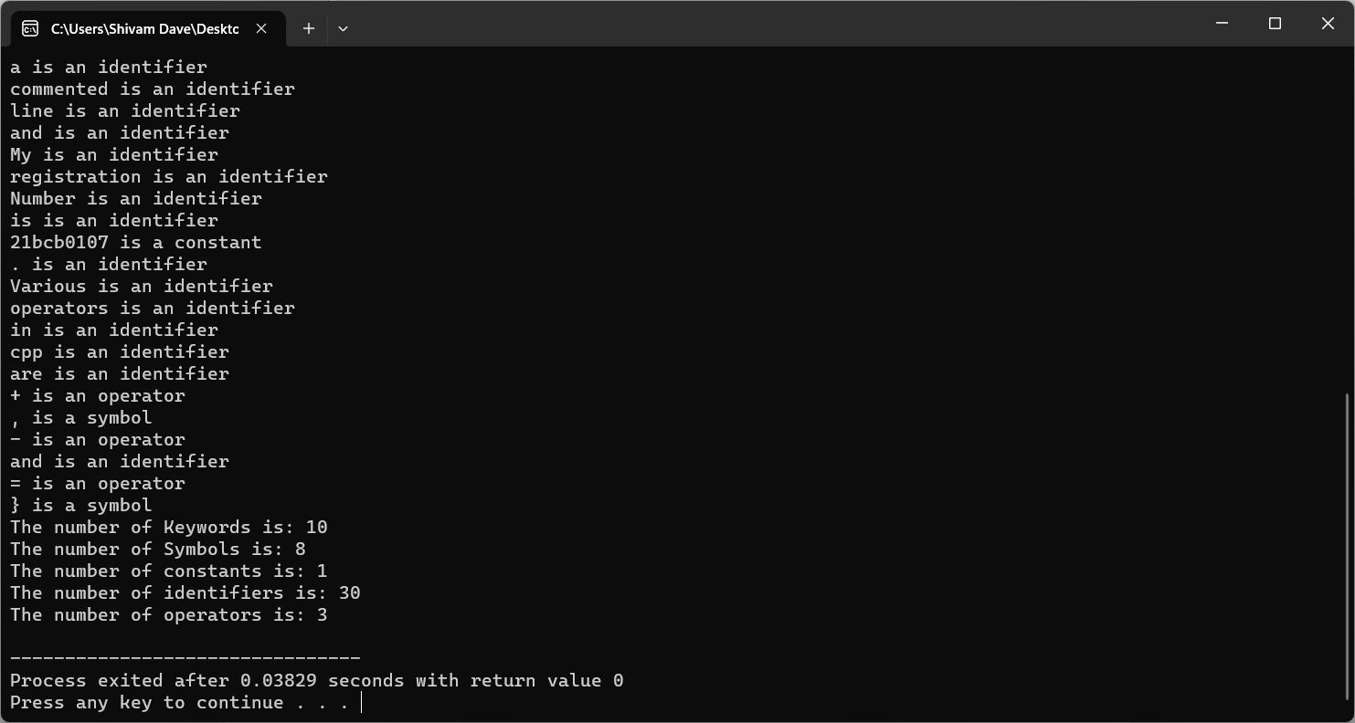

**Code for a particular user input code instead of a file:**

#include <stdio.h>

#include <stdlib.h>

#include <ctype.h>

#include <string.h>

// Token types

typedef enum {

TOK_IDENTIFIER,

TOK_NUMBER,

TOK_OPERATOR,

TOK_DELIMITER,

TOK_KEYWORD,

TOK_UNKNOWN

} TokenType;

// Token structure

typedef struct {

TokenType type;

char value[50];

} Token;

// Function to check if a character is a delimiter

int isDelimiter(char ch) {

char delimiters[] = " \t\n,;(){}[]";

int i;

for ( i = 0; i < strlen(delimiters); i++) {

if (ch == delimiters[i])

return 1;

}

return 0;

}

// Function to check if a character is an operator

int isOperator(char ch) {

char operators[] = "+-*/%=";

int i;

for (i = 0; i < strlen(operators); i++) {

if (ch == operators[i])

return 1;

}

return 0;

}

// Function to check if a string is a keyword

int isKeyword(char* str) {

char keywords[][10] = {"int", "float", "char", "if", "else", "for", "while", "do", "return"};

int numKeywords = sizeof(keywords) / sizeof(keywords[0]);

int i;

for (i = 0; i < numKeywords; i++) {

if (strcmp(str, keywords[i]) == 0)

return 1;

}

return 0;

}

// Function to tokenize the input string

void tokenize(char* input) {

int length = strlen(input);

int i = 0;

while (i < length) {

// Skip whitespace

if (isspace(input[i])) {

i++;

continue;

}

// Handle identifiers and keywords

if (isalpha(input[i])) {

int j = 0;

char identifier[50];

while (isalnum(input[i])) {

identifier[j] = input[i];

i++;

j++;

}

identifier[j] = '\0';

Token token;

strcpy(token.value, identifier);

if (isKeyword(identifier)) {

token.type = TOK_KEYWORD;

printf("Keyword: %s\n", token.value);

} else {

token.type = TOK_IDENTIFIER;

printf("Identifier: %s\n", token.value);

}

continue;

}

// Handle numbers

if (isdigit(input[i])) {

int j = 0;

char number[50];

while (isdigit(input[i])) {

number[j] = input[i];

i++;

j++;

}

number[j] = '\0';

Token token;

strcpy(token.value, number);

token.type = TOK_NUMBER;

printf("Number: %s\n", token.value);

continue;

}

// Handle operators

if (isOperator(input[i])) {

Token token;

token.value[0] = input[i];

token.value[1] = '\0';

token.type = TOK_OPERATOR;

printf("Operator: %s\n", token.value);

i++;

continue;

}

// Handle delimiters

if (isDelimiter(input[i])) {

Token token;

token.value[0] = input[i];

token.value[1] = '\0';

token.type = TOK_DELIMITER;

printf("Delimiter: %s\n", token.value);

i++;

continue;

}

// Handle unknown characters

Token token;

token.value[0] = input[i];

token.value[1] = '\0';

token.type = TOK_UNKNOWN;

printf("Unknown: %s\n", token.value);

i++;

}

}

// Main function

int main() {

char input[100];

printf("Enter input string: ");

fgets(input, sizeof(input), stdin);

// Remove trailing newline character

input[strcspn(input, "\n")] = '\0';

// Tokenize the input string

tokenize(input);

return 0;

}

**OUTPUT Screenshot:** 